Museum Box Directions for Teachers

Museum Box is an on-line program that will let you or your students make infographic cubes using: text, graphics, sounds, video, & outside links. You choose how many cubes you want students to use.

There is a Gallery of example cubes & boxes to view. Hope you find this program useful for your classes.

Go to Museum Box Homepage

Click on Register your school

Click on

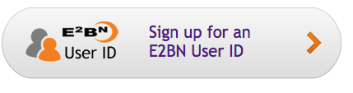

Select country - United States

TYpe in: Unionville high school
750 Unionville Road
Kennett Square
PA
19348
my name : Kathy DiFilippo ( contact person)
6103471600
kdifilippo@ucfsd.net

click CONTINUE

USE EXISTING SCHOOL

Then type your info.

NOW you’re ready with your own account.

When adding students, you can either add one at a time or upload a class roster from your computer.

There are many useful tutorials.

